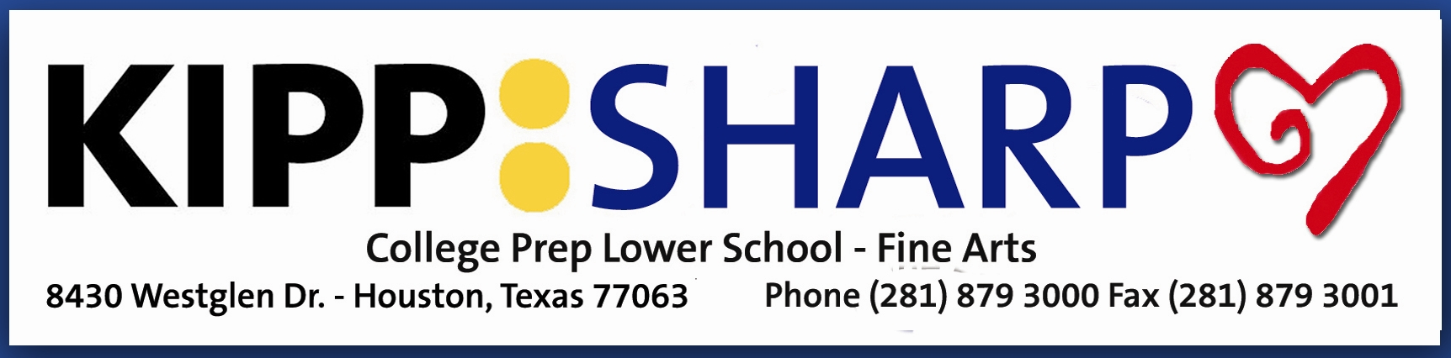

The KIPP SHARP Singers, founded in 2009 by Laura Taylor, offers fourth graders from KIPP SHARP College Prep Lower School an opportunity to experience and perform diverse music outside the classroom. Working with a variety of community partners the choir offers students possibilities to engage in the world beyond their neighborhood.

Under Ms. Taylor’s direction the choir has performed in Carnegie Hall, the United States Capitol, Georgetown University, Lincoln Memorial, Jefferson Memorial, The Music Center at Strathmore, the Texas State Capitol, The University of Texas at Austin, Roundtop Festival Hill, Jones Hall, Hobby Center, Wortham Theater, The Centrum and Rice University. In addition, the choir has enjoyed singing our National Anthem at Texans and Dynamo games for several years as well as participating numerous times in the annual City of Houston Mayor’s Tree Lighting Ceremony at City Hall and performing at many galas and community events around our great city.

KIPP SHARP is a Title I school in the Gulfton/Sharpstown area of Houston. KIPP Texas Public Schools is a nonprofit public charter school network, dedicated to preparing students in educationally underserved communities for college success and choice-filled lives.

